

**LAPORAN PRAKTIKUM 3**

**PEMROGRAMAN VISUAL**



Disusun Oleh :

Nama : Luthfi Khairul Rafiq

NIM : 200511103

Kelas : TI20C

**Jurusan Teknik Informatika**

**Fakultas Teknik**

**Universitas Muhammadiyah Cirebon (UMC)**

**2023**

**KATA PENGANTAR**

Puji syukur kita panjatkan kehadirat Allah SWT yang telah memberikan rahmat dan hidayah-Nya sehingga saya dapat menyelesaikan tugas yang berjudul “Laporan Praktikum Pemrograman Visual”.

Adapun tujuan dari penulisan laporan ini adalah untuk memenuhi tugas pada matakuliah Pemrograman Visual. Selain itu, laporan ini juga bertujuan untuk menambah ilmu tentang Object Oriented Programming (OOP).

Saya menyadari, tugas yang saya tulis ini masih jauh dari kata sempurna. Oleh karena itu, kritik dan saran yang membangun saya butuhkan demi kesempurnaan laporan praktikum ini.

Cirebon, 9 April 2023

Penyusun

**APLIKASI SEDERHANA MENGGUNAKAN**

**TEKNIK PEMROGRAMAN TERSTRUKTUR**

1. Menghitung Luas dan Keliling Belahketupat

**Source code :**

Public Class Form1

Private Sub Label5_Click(sender As Object, e As EventArgs) Handles Label5.Click

End Sub

Private Function HitungLuas(diagonal1 As Integer, diagonal2 As Integer) As Integer

Dim luas As Integer

luas = 0.5 * diagonal1 * diagonal2

Return luas

End Function

Private Function HitungKeliling(sisi As Integer) As Integer

Dim keliling As Integer

keliling = 4 * sisi

Return keliling

End Function

Private Sub btnHitung_Click(sender As Object, e As EventArgs) Handles btnHitung.Click

Dim diagonal1, diagonal2, sisi, luas, keliling As Integer

diagonal1 = txtDiagonal1.Text

diagonal2 = txtDiagonal2.Text

sisi = txtSisi.Text

luas = HitungLuas(diagonal1, diagonal2)

keliling = HitungKeliling(sisi)

txtLuas.Text = Str(luas)

txtKeliling.Text = Str(keliling)

End Sub

End Class

**Hasil Program :**

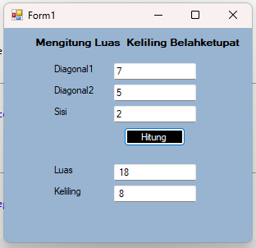

1. Menghitung Luas dan Keliling Layang-layang

**Source Code :**

Public Class Form1

Private Sub Label5_Click(sender As Object, e As EventArgs) Handles Label5.Click

End Sub

Private Function HitungLuas(diagonal1 As Integer, diagonal2 As Integer) As Integer

Dim luas As Integer

luas = (diagonal1 * diagonal2) / 2

Return luas

End Function

Private Function HitungKeliling(sisi1 As Integer, sisi2 As Integer, sisi3 As Integer, sisi4 As Integer) As Integer

Dim keliling As Integer

keliling = sisi1 + sisi2 + sisi3 + sisi4

Return keliling

End Function

Private Sub btnHitung_Click(sender As Object, e As EventArgs) Handles btnHitung.Click

Dim diagonal1, diagonal2, sisi1, sisi2, sisi3, sisi4, luas, keliling As Integer

diagonal1 = txtDiagonal1.Text

diagonal2 = txtDiagonal2.Text

sisi1 = txtSisi1.Text

sisi2 = txtSisi2.Text

sisi3 = txtSisi3.Text

sisi4 = txtSisi4.Text

luas = HitungLuas(diagonal1, diagonal2)

keliling = HitungKeliling(sisi1, sisi2, sisi3, sisi4)

txtLuas.Text = Str(luas)

txtKeliling.Text = Str(keliling)

End Sub

End Class

**Hasil program :**

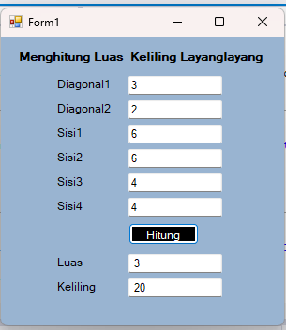

1. Menghitung Luas dan Keliling Lingkaran

**Source Kode :**

Public Class Form1

Private Sub Label3_Click(sender As Object, e As EventArgs) Handles Label3.Click

End Sub

Private Function HitungLuas(jarijari As Integer) As Integer

Dim luas As Integer

luas = 3.14 * jarijari * jarijari

Return luas

End Function

Private Function HitungKeliling(jarijari As Integer) As Integer

Dim keliling As Integer

keliling = 2 * 3.14 * jarijari

Return keliling

End Function

Private Sub btnHitung_Click(sender As Object, e As EventArgs) Handles btnHitung.Click

Dim jarijari, luas, keliling As Integer

jarijari = txtJarijari.Text

luas = HitungLuas(jarijari)

keliling = HitungKeliling(jarijari)

txtLuas.Text = Str(luas)

txtKeliling.Text = Str(keliling)

End Sub

End Class

**Hasil Program :**

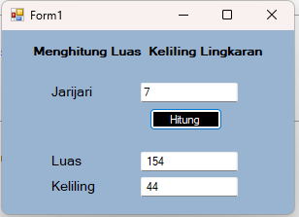

1. Menghitung Luas dan Keliling Persegi Panjang

**Source Kode :**

Public Class Form1

Private Sub Label5_Click(sender As Object, e As EventArgs) Handles Label5.Click

End Sub

Private Function HitungLuas(panjang As Integer, lebar As Integer) As Integer

Dim luas As Integer

luas = panjang * lebar

Return luas

End Function

Private Function HitungKeliling(panjang As Integer, lebar As Integer) As Integer

Dim keliling As Integer

keliling = 2 * (panjang + lebar)

Return keliling

End Function

Private Sub btnHitung_Click(sender As Object, e As EventArgs) Handles btnHitung.Click

Dim panjang, lebar, luas, keliling As Integer

panjang = txtPanjang.Text

lebar = txtLebar.Text

luas = HitungLuas(panjang, lebar)

keliling = HitungKeliling(panjang, lebar)

txtLuas.Text = Str(luas)

txtKeliling.Text = Str(keliling)

End Sub

End Class

**Hasil program :**

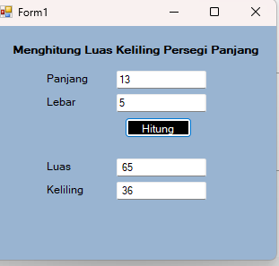

1. Menghitung Luas dan Keliling Segitiga

**Source Kode :**

Public Class Form1

Private Sub Label5_Click(sender As Object, e As EventArgs) Handles Label5.Click

End Sub

Private Function HitungLuas(alas As Integer, tinggi As Integer) As Integer

Dim luas As Integer

luas = 1 / 2 * alas * tinggi

Return luas

End Function

Private Function HitungKeliling(sisi As Integer) As Integer

Dim keliling As Integer

keliling = sisi + sisi + sisi

Return keliling

End Function

Private Sub Button1_Click(sender As Object, e As EventArgs) Handles Button1.Click

Dim alas, tinggi, sisi, luas, keliling As Integer

alas = txtAlas.Text

tinggi = txtTinggi.Text

sisi = txtSisi.Text

luas = HitungLuas(alas, tinggi)

keliling = HitungKeliling(sisi)

txtLuas.Text = Str(luas)

txtKeliling.Text = Str(keliling)

End Sub

End Class

**Hasil program :**

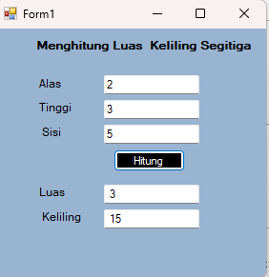

1. Menghitung Luas dan Volume Balok

**Souce Kode :**

Public Class Form1

Private Sub Label5_Click(sender As Object, e As EventArgs) Handles Label5.Click

End Sub

Private Function HitungLuas(panjang As Integer, lebar As Integer, tinggi As Integer) As Integer

Dim luas As Integer

luas = 2 * (panjang * lebar + panjang * tinggi + lebar * tinggi)

Return luas

End Function

Private Function HitungVolume(panjang As Integer, lebar As Integer, tinggi As Integer) As Integer

Dim volume As Integer

volume = panjang * lebar * tinggi

Return volume

End Function

Private Sub btnHitung_Click(sender As Object, e As EventArgs) Handles btnHitung.Click

Dim panjang, lebar, tinggi, luas, volume As Integer

panjang = txtPanjang.Text

lebar = txtLebar.Text

tinggi = txtTinggi.Text

luas = HitungLuas(panjang, lebar, tinggi)

volume = HitungVolume(panjang, lebar, tinggi)

txtLuas.Text = Str(luas)

txtVolume.Text = Str(volume)

End Sub

End Class

**Hasil Program :**

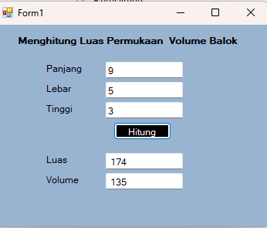

1. Menghitung Luas dan Volume Bola

**Source Kode :**

Public Class Form1

Private Sub Label4_Click(sender As Object, e As EventArgs) Handles Label4.Click

End Sub

Private Function HitungLuas(jarijari As Integer) As Integer

Dim luas As Integer

luas = 4 * 3.14 * jarijari * jarijari

Return luas

End Function

Private Function HitungVolume(jarijari As Integer) As Integer

Dim Volume As Integer

Volume = 3 / 4 * 3.14 * jarijari * jarijari * jarijari

Return Volume

End Function

Private Sub btnHitung_Click(sender As Object, e As EventArgs) Handles btnHitung.Click

Dim jarijari, luas, volume As Integer

jarijari = txtJarijari.Text

luas = HitungLuas(jarijari)

volume = HitungVolume(jarijari)

txtLuas.Text = Str(luas)

txtVolume.Text = Str(volume)

End Sub

End Class

**Hasil Program :**

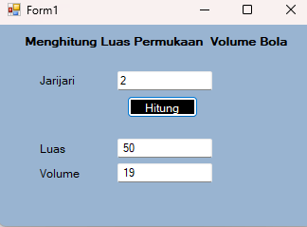

1. Menghitung Luas dan Volume Kerucut

**Source Kode :**

Public Class Form1

Private Sub Label1_Click(sender As Object, e As EventArgs) Handles Label1.Click

End Sub

Private Function HitungLuas(jarijari As Integer, sisimiringa As Integer) As Integer

Dim luas As Integer

luas = 3.14 * jarijari * (jarijari + sisimiringa)

Return luas

End Function

Private Function HitungVolume(jarijari As Integer, tinggi As Integer) As Integer

Dim volume As Integer

volume = 1 / 3 * 3.14 * jarijari * jarijari * tinggi

Return volume

End Function

Private Sub Button1_Click(sender As Object, e As EventArgs) Handles btnHitung.Click

Dim jarijari, tinggi, sisimiringa, luasp, volume As Integer

jarijari = txtJarijari.Text

tinggi = txtTinggi.Text

sisimiringa = txtSisimiring.Text

luasp = HitungLuas(jarijari, sisimiringa)

volume = HitungVolume(jarijari, tinggi)

txtLuas.Text = Str(luasp)

txtVolume.Text = Str(volume)

End Sub

End Class

**Hasil Program :**

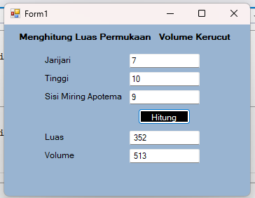

1. Menghitung Luas dan Volume Kubus

**Souce kode :**

Public Class Form1

Private Sub Label1_Click(sender As Object, e As EventArgs) Handles Label1.Click

End Sub

Private Function HitungLuas(sisi As Integer) As Integer

Dim luas As Integer

luas = 6 * sisi * sisi

Return luas

End Function

Private Function HitungVolume(sisi As Integer) As Integer

Dim volume As Integer

volume = sisi * sisi * sisi

Return volume

End Function

Private Sub btnHitung_Click(sender As Object, e As EventArgs) Handles btnHitung.Click

Dim sisi, luas, volume As Integer

sisi = Val(txtSisi.Text)

luas = HitungLuas(sisi)

volume = HitungVolume(sisi)

txtLuas.Text = Str(luas)

txtVolume.Text = Str(volume)

End Sub

End Class

**Hasil Program :**

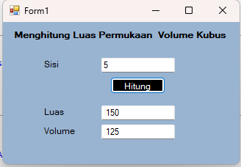

1. Menghitung luas dan Volume Tabung

**Source Kode :**

Public Class Form1

Private Sub Label4_Click(sender As Object, e As EventArgs) Handles Label4.Click

End Sub

Private Function HitungLuas(jarijari As Integer, tinggi As Integer) As Integer

Dim luas As Integer

luas = 2 * 3.14 * jarijari * (jarijari + tinggi)

Return luas

End Function

Private Function HitungVolume(jarijari As Integer, tinggi As Integer) As Integer

Dim volume As Integer

volume = 3.14 * jarijari * jarijari * tinggi

Return volume

End Function

Private Sub Button1_Click(sender As Object, e As EventArgs) Handles btnHitung.Click

Dim jarijari, tinggi, luasp, volume As Integer

jarijari = txtJarijari.Text

tinggi = txtTinggi.Text

luasp = HitungLuas(jarijari, tinggi)

volume = HitungVolume(jarijari, tinggi)

txtLuas.Text = Str(luasp)

txtVolume.Text = Str(volume)

End Sub

End Class

**Hasil program :**

